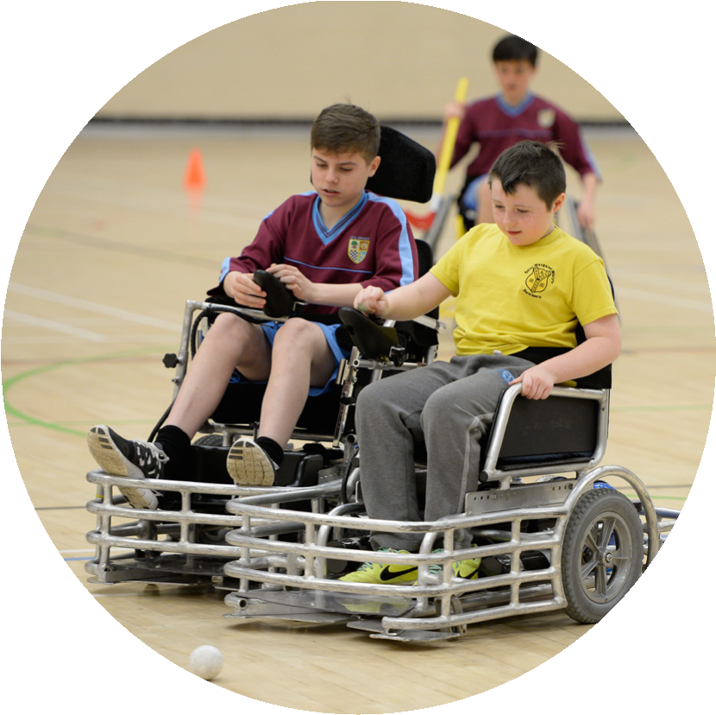
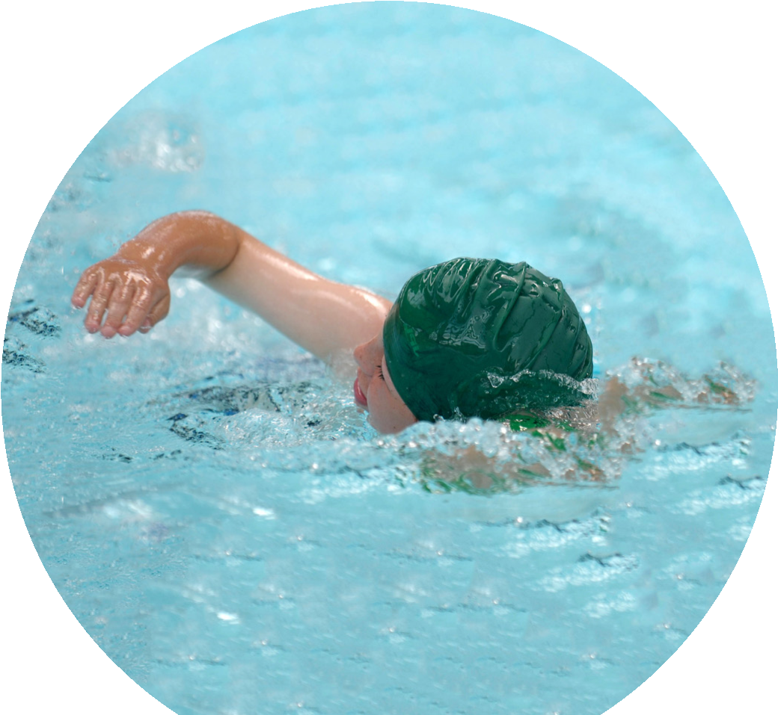
Evidencing the
impact of the
imary PE and
sport premium

Website Reporting Tool
Revised July 2022
Created by
Commissioned by

It is important that your grant is used effectively and based on school need. The Education Inspection Framework makes clear there will be a focus on ‘whether leaders and those responsible for governors all understand their respective roles and perform these in a way that enhances the effectiveness of the school’.

Under the Quality of Education Ofsted inspectors consider:
Intent - Curriculum design, coverage and appropriateness
Implementation - Curriculum delivery, Teaching (pedagogy) and Assessment
Impact - Attainment and progress

To assist schools with common transferable language this template has been developed to utilise the same three headings which should make your plans easily transferable between working documents.
Schools must use the funding to make additional and to the quality of Physical Education, School Sport and Physical they offer. This means that you should use the Primary PE and
- Develop or add to the PESSPA activities that your school already offer
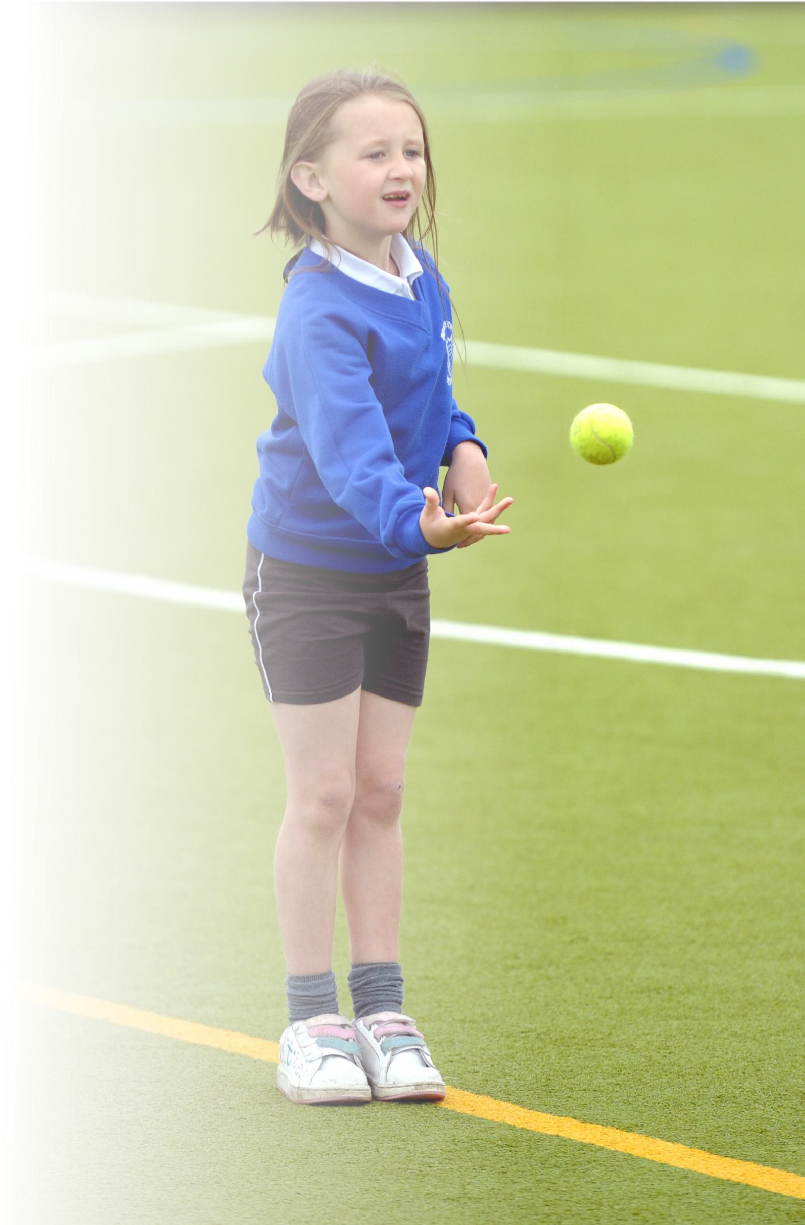
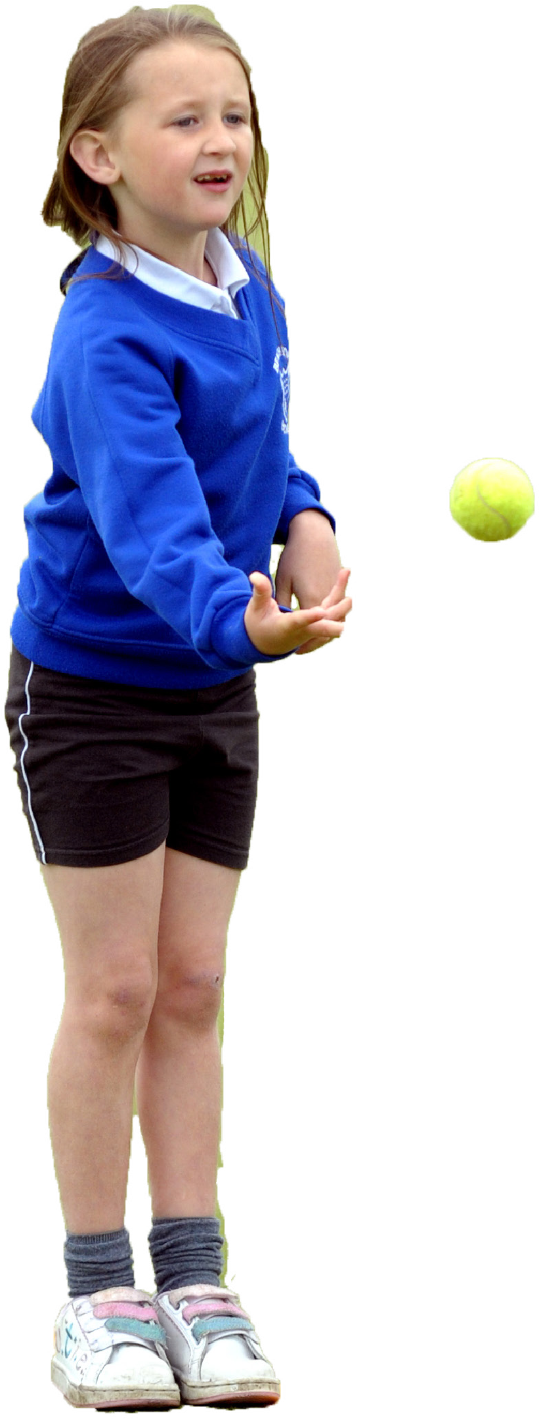
- Build capacity and capability within the school to ensure that improvements made now will benefit pupils joining the school in future years
sustainable

improvements
(
PESSPA)
Activity
sport
premium
to:

- The Primary PE and sport premium should not be used to fund capital spend projects; the school’s budget should fund these.
Please visit gov.uk for the revised DfE guidance including the 5 key indicators across which schools should demonstrate an improvement. This document will help you to review your provision and to report your spend. DfE encourages schools to use this template as an effective way of meeting the reporting requirements of the Primary PE and sport premium.
We recommend you start by reflecting on the impact of current provision and reviewing the previous spend.
Schools are required to publish details of how they spend this funding, including any under-spend from 2021/2022, as well as on the impact it has on pupils’ PE and sport participation and attainment. All funding must be spent by 31st July 2022.
We recommend regularly updating the table and publishing it on your website throughout the year. This evidences your ongoing self-evaluation of how you are using the funding to secure maximum, sustainable impact. Final copy must be posted on your website by the end of the academic year and no later than the 31st July 2021. To see an example of how to complete the table please click HERE.
Swimming Data
Please report on your Swimming Data below.

Details with regard to funding
Please complete the table below.

Total amount carried over from 2021/22 | £0
Total amount allocated for 2021/22 | £17,491
How much (if any) do you intend to carry over from this total fund into 2021/22? | £0
Total amount allocated for 2022/23 | £17,540
Total amount of funding for 2022/23. To be spent and reported on by 31st July 2023. | £17,540
Meeting national curriculum requirements for swimming and water safety.
N.B. Complete this section to your best ability. For example you might have practised safe self-rescue techniques on dry land which you can then transfer to the pool when school swimming restarts.
Due to exceptional circumstances priority should be given to ensuring that pupils can perform safe self rescue even if they do not fully meet the first two requirements of the NC programme of study
What percentage of your current Year 6 cohort swim competently, confidently and proficiently over a distance of at least 25 metres?  N.B. Even though your pupils may swim in another year please report on their attainment on leaving primary school at the end of the summer term 2020. Please see note above |  | 76%
What percentage of your current Year 6 cohort use a range of strokes effectively [for example, front crawl, backstroke and breaststroke]? Please see note above |  | 9%
What percentage of your current Year 6 cohort perform safe self-rescue in different water-based situations? |  | 18%
Schools can choose to use the Primary PE and sport premium to provide additional provision for swimming but this must be for activity over and above the national curriculum requirements. Have you used it in this way? |  | No
Action Plan and Budget Tracking
Capture your intended annual spend against the 5 key indicators. Clarify the success criteria and evidence of impact that you intend to measure to evaluate for pupils today and for the future.

Academic Year: 2022/2023 | Total fund allocated: £17,540 | Impact Statement - July 2023
Key indicator 1: The engagement of all pupils in regular physical activity – Chief Medical Officers guidelines recommend that primary school pupils undertake at least 30 minutes of physical activity a day in school |  |  |  | Percentage of total allocation:
 |  |  |  | 19%
Intent | Key Achievements/What worked well/Impact
 |  | Funding allocated: |  | Sustainability and suggested next steps:
Increase physical activity and participation in EYFS, KS1 & KS2 at lunchtime, to engage pupils in at least 30mins of physical activity a day in school.  To continue to promote active travel to and from school through walk to school  Lunchtime Organisers and sports leaders to organise activities to increase physical activity and exercise.  Develop and expand Extra Curriculum Programme across the school.  Embed initiatives to develop knowledge of healthy living and active lifestyles across the whole school including EYFS | - Outdoor play equipment was purchased which encouraged more children to participate in physical activity at break and lunchtimes.  - Sports leaders were appointed to boost activity and competition. Observations at play time and dinnertime show that sports leaders are effective in their role in supporting physical activity at break times and dinner times.  - We continued to work in partnership with the Manchester PE Association and local schools, to improve participation rates and increase participation opportunities for all children. This included cross country and football.  - We Investigated and commissioned a new sporting initiative involving skipping ropes which has engaged more children in physical activity during break times. Staff and Lunctime Organisers all received skipping training.  - We continued with healthy school food and drink policy, offering KS1 milk scheme, KS2 milk and fruit scheme and ensured that the school provides a healthy and nutritious lunchtime meal including fresh drinking water and milk.  - We have continued to audit food at breakfast and after school club ensuring children are offered healthy options. This has included ensuring that the ‘free bagels’ for all follows the agreed portion control for each class.  - We have shared many children’s ‘outside school’ sporting achievements in Good News Assembly. This has included football, dancing, swimming and many more sports.  - We have continued to promote whole school physical activity and sports participation through Sports day and our Health and Fitness day. 100% of children participated and activities included healthy eating, hygiene, relaxation.  - We promoted health and fitness through a range of activities. We have also encouraged the children to compete against themselves to improve scores and times during PE sessions. | £3,270 | - Observation  - School blog  - Website  - School competitions  - Science/PSHE work  - Healthy lunch boxes  - Water available in classrooms  - Pupils are knowledgeable regarding foods and healthy lifestyles.  - Teachers to regularly take pupils out for Daily runs | Maintain / improve the provision and equipment for lunch time activities to increase physical activity. CITC to support sports leaders  Engage children in 30minutes of physical activity every day in school through break, lunch and after school provision.  Continue to develop Sports Leaders to organise, run and promote lunch time sports and activities.  Organise whole school sports events / days to encourage mass participation.  Continue to promote active travel to and from school.
Key indicator 2: The profile of PESSPA being raised across the school as a tool for whole school improvement |  |  |  | Percentage of total allocation:
 |  |  |  | 17%
Intent | Key Achievements/What worked well/Impact |  | Impact
 | : | Funding allocated: | Evidence of impact: what do pupils now know and what can they now do? What has changed?: | Sustainability and suggested next steps:
Children will be provided with a wider range of sports which will increase the children’s participation in sport.  A wider range of sporting house competitions to be arranged throughout the year, during lunchtimes, after school and within the curriculum, to raise the profile of sport and increase participation.  Re-introduce the Sports Leaders to represent Pupil Voice and allow the children to have a say in the sports on offer  Opportunities for parents to be involved in sporting events (e.g. Sports Days…).  Newsletters / website / twitter to further inform and promote sport within the school.  Continue to promote sport and sporting achievement throughout the school during weekly praise assemblies. Intended impact on pupils: - All pupils wanting to be active and to enjoy taking part in a range of sport, exercise and physical activity. All pupils understanding the importance sport and physical activity plays in a healthy lifestyle. All pupils aware of the sporting opportunities on offer to the | A range of after school sports has been extended this year and all clubs have been full for the entire year. The offer of clubs changes on a termly basis so that children can participate in a wider range of clubs. Pupil Voice has shown that children have enjoyed the clubs on offer and the variety of choices available especially forest school and yoga.  We have specifically targeted children who have not participated in sporting clubs before whilst also offering an opportunity for children to participate in sports that they may not otherwise get to try. Eg Racket Cubed Squash club and Yoga  Sports Leaders have focused on engaging younger children in sporting activities. This was supported in a pupil voice activity where pupils in Y5 stated that ‘the sports Leaders were good role-models in the way they helped the younger children at break and dinner times’.  Games to be organised within year groups and with local schools both after school and during the school day  Parents were invited to take part in Sports day. Over 35 parents participated in the parents race.  A newletter showing the development of skills across our Pe Curriculum from Nursery to Year 6 was shared on the school’s website on ………..  Children have been encouraged to lead on fitness within PE lessons and devise exercises / activities that the class can complete. (e.g. warm ups and stretches and creating and explaining their own games | £3,000 | Sports and Health and Fitness themed days.  Participation in Manchester PE Association competitions.  Participation in home fixtures and competitions in football.  Whole school sporting events  Medals and trophies awarded  School Website  All pupils aware of sporting opportunities available to them; children want to be active and understand the importance of being active.  All pupils understanding the importance sport and physical activity plays in a healthy lifestyle. | Continue to raise the profile of sport and encourage participation for all.  Allow local clubs into school to help coach and promote their sports.  Sports Leaders to continue to lead Pupil Voice.  PE lead given designated time to promote the sport within school.  Sporting events regularly advertised around the school and to parents through the school website, twitter, parent mail and newsletters

Key indicator 3: Increased confidence, knowledge and skills of all staff in teaching PE and sport |  |  |  | Percentage of total allocation:
 |  |  |  | 47%
Intent | Key Achievements/What worked well/Impact |  | Impact
 |  | Funding allocated: | Evidence of impact: what do pupils now know and what can they now do? What has changed?: | Sustainability and suggested next steps:
Improving subject knowledge.  Associated issues:  - Curriculum knowledge  - Knowledge of how to progress skills/plan effective lessons.  - Knowledge of expected standards.  Knowledge of assessment for PE | - An evaluation of the current scheme for PE in terms of outcomes for pupils has been undertaken. Evaluation shows that there has been more positive attitude to health and wellbeing. As a result of the audit we have decided to update the current scheme in use and are currently trialling a new scheme for PE.  - Manchester City provided support across the school which has led to increased confidence amongst staff to deliver high quality PE. CITC have also provided staff training to all staff.  - We have linked with MCFC to develop assessment for PE in school.  • NP provide ongoing support and advice for all staff in the teaching of PE and structure of lessons.  Pupil Voice activity showed that they liked the variety of activities, using the equipment and showcasing what they had learnt. They enjoyed the warm up games and learning ball skills and using different equipment and apparatus in gymnastics. They get to learn a lot of new things They said that PE is fun and you get to work together in teams whilst exercising at the same time. They like the mix of indoor and outdoor and the learning how to better their skills. Children said they had learnt games skills, such as throwing and catching, bouncing the ball, marking and defending, attacking, dribbling, passing and receiving. Inside, they had learnt symmetrical balances, jumping, rolling and the importance of agility in gymnastics. They have also learnt correct technique and safety and how to hold equipment correctly (carrying gym equipment). • | £8,270 | More confident and competent staff  • Enhanced quality of teaching and learning  • Improved standards  • Continued high level of pupil participation  • Enhanced, inclusive curriculum provision  • Positive attitudes to health and wellbeing  • Improved behaviour  • Improved pupil attitudes to PE | - PE subject Leader to support new staff in school with planning for delivery of physical education and planning from CITC.  - Arrange team teaching opportunities and supportive lesson observations in order to develop the quality of teaching, learning and assessment.  - PE subject Leader to identify any staff who need further support and to provide appropriate professional learning. - Further professional learning opportunities for staff who request it.  - PE Subject Leader to monitor and to provide support as appropriate in order to ensure progress and achievement are maintained by all pupils.
Key indicator 4: Broader experience of a range of sports and activities offered to all pupils |  |  |  | Percentage of total allocation:
 |  |  |  | 11%
Intent | Key Achievements/What worked well/Impact |  | Impact
 |  | Funding allocated: | Evidence of impact: what do pupils now know and what can they now do? What has changed?: | Sustainability and suggested next steps:
Use of pupil voice to ensure sports on offer are appealing to the children.  Continue to develop the Extra-Curricular Program across the school and to enter Manchester PE Association competitions.  Outside agencies and clubs to come into school and offer a range of sports to the children in KS1 and KS2.  Increase the amount of opportunities for children to participate in outdoor pursuits | Sports leaders have been involved with PE Co-Ordinator in designing enrichment timetables. This has impacted positively on all areas of PE and sport.  The subject Leader has carried out an audit, monitored Pe lessons and the quality of the PE Curriculum on offer ensuring that the breadth and balance within the PE curriculum is of a high standard.  The PE Co-Ordinator carried out a pupil voice activity. The outcomes led to a range of additional sports club put on offer ie Yoga and girl’s football.  We have continue to formulate links with a range of outside agencies / clubs to come into school to offer a range of sports, both during and outside of curriculum time.  There have been two residential opportunities for outdoor pursuits for children in Year 6 and Year 5. Pupil voice show that resilience, team work and self motivation were all improved as a result of these opportunities. | £2,000 | All pupils given a broader experience in PE and extra-curricular activities, as well as a wider range of sports being offered throughout the day | Continue supporting sports leaders to seek pupil voice and respond to this appropriately by sustaining specific activities across the school and introducing new sports  Continue to seek Outside agencies / clubs to come into school to offer a range of sporting opportunities and develop further interest and links with local clubs, enabling children to participate outside of school.  Provide new opportunities to try some sports that they may not otherwise get the chance to play

Key indicator 5: Increased participation in competitive sport |  |  |  |  |  | Percentage of total allocation:
 |  |  |  |  |  | 6%
Intent |  | Key Achievements/What worked well/Impact |  |  | Impact
 |  |  |  | Funding allocated: | Evidence of impact: what do pupils now know and what can they now do? What has changed?: | Sustainability and suggested next steps:
Children to be provided with a range of opportunities to participate and compete in competitive sport.  Develop intra-school competitions in conjunction with partner-school as part of "deeper learning" days.  Increased participation in sporting activities to include Intra & Inter-School competitions. |  | - We have Increased our involvement of school competitions.  - Use Man City coach to identify talented individuals, to then link with teachers to encourage outside sporting involvement.  - Funding from this grant has been used to transport pupils to competitions and  outdoor residentials  More teaching staff have taken children to sports competitions during the school day. We have used some of the grant to pay for this to happen by providing cover.  . |  | £1,000 | More pupils will participate in competitive sport, including those with SEN.  Regularly competing in a range of sports against other schools.  Entrance into Manchester PE Association Competitions  Friendly fixtures against local schools.  • Cover for staff to take teams to competitions  Photos / Website / Twitter and Newsletter. • Fixture lists. • School Games Gold Mark maintained / Platinum Achieved. • Regular house competitions in school.  More pupils will participate in competitive sport. | Continue to provide transport to sporting competitions & fixtures.  Continue to arrange cover for staff to take children to competitions during the school day.  Continue to arrange games and tournaments with local schools.  Continue to run sporting competitions during lunch times.  Continue to provide opportunities for more children to compete in competitive sport.
Signed off by
Head Teacher: | Catherine Gordon
Date: | June 2023
Subject Leader: | Nicola Pugh
Date: | June 2023
Governor: | Charles Flannery
Date: | June 2023

