The Roman Catholic Federation of Holy Name and Our Lady’s

** **

**Freedom of Information Policy**

**HOLY NAME MISSION STATEMENT**

The Holy Name Primary School is a voluntary aided, inclusive, Roman Catholic School serving the children of the Our Lady’s with St Alphonsus and neighbouring parishes.

The school exists to help the Catholic Community fulfil the promise made to each child when welcomed in Baptism by the promotion of Catholic values in school. This is undertaken in partnership within the home and parish.

Recognising the variety of children’s backgrounds, the Governors and staff seek to be sensitive to and cater for their individual needs. We work to create a safe and secure environment with consistency, tolerance and generosity of time for all members of our school community.

We emphasise the positive aspects of all parts of school life, teaching the children about their value and worth and at the same time having high expectations in relation to academic and personal development.

***At Our Lady’s, we seek at all times to be a witness to Jesus Christ. We remember this when putting our policies into practice.***

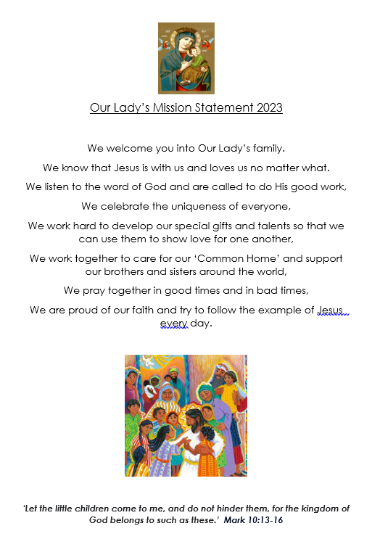

1. **INTRODUCTION**

The Roman Catholic Federation of Holy Name and Our Lady’s recognises the need to hold information in accordance with the Freedom of Information Act 2000 (“the Act”) and make it available to the public in accordance with provisions of the Act, subject to any legal exemptions.

Any reference in Act to “public authorities” applies to schools.

1. **PUBLICATION SCHEME**

The Freedom of Information Act (2000) (FOI) requires all Public Authorities (including schools) to produce a register of the types of information it will routinely make available to the public.

[Name of School] has adopted the model publication scheme approved by the Information Commissioner.

[Name of School’s] publication scheme sets out the seven classes of information identified in the model publication scheme:

* Who we are and what we do
* What we spend and how we spend it
* What our priorities are and how we are doing
* How we make decisions
* Our policies and procedures
* Lists and registers
* The services we offer

Information will be provided on the School’s website wherever possible. However, some information may only be available in hard copy. If it is not possible to access the information via the website, the School will make appropriate arrangements for the information to be made available upon request to [Job Title] at [Name of School].

The purpose of the publication scheme is to make the greatest amount of information readily available at minimum inconvenience and cost to the requestor. Any charges made by the school will be kept to a minimum. Material which is published and accessed on a website will be provided free of charge.

Charges may be made to cover the School’s costs such as: photocopying, postage and packaging and/or any costs directly incurred by the School as result of providing the information. If a charge is to be made, confirmation of the charge will be given before the information is provided and payment may be required prior to provision of the information.

1. **MAKING A REQUEST UNDER THE FREEDOM OF INFORMATION ACT**

Any requests for Information held by the school that is not published under the School’s publication scheme should be made in writing to the school via letter or email.

The request will then be acknowledged in writing and if necessary, clarification will be sought on what is being asked for.

The School will usually respond to the request within 20 working days in one of the following ways:

* By providing the information requested;
* Confirming that it does not hold the information requested;
* Confirming that the information requested is already publicly available and where it can be obtained from; or
* Explaining whether any/all of the information is exempt from disclosure.

1. **REFUSING A REQUEST**

The School will try to make as much information available as possible. However, sometimes there may be a valid reason for withholding information. Examples of when we may withhold information include:

* School intends to publish the information in the future;
* The law states the information must not be released.
* Disclosure would:
  + Breach confidentiality;
  + Breach the Data Protection Legislation;
  + Breach the public interest.

Reasons will be provided if School decides to withhold information.

1. **CHARGES**

Most information requested will be provided free of charge, although School may charge a fee for the photocopying/printing/postage of larger documents and where it is not available in the Publications Scheme.

School will not charge for time spent dealing with a request but there is no obligation to provide information if it would involve more than 18 hours work. In such cases, school will make contact with the requestor and discuss options.

If a charge is to be made, confirmation of the charge will be given before the information is provided and payment may be required prior to provision of the information.

1. **PURPOSE OF INFORMATION PROVIDED**

Any information provided by School following a request made in line with the Act may only be used for personal purposes.

1. **COMPLAINTS**

Any complaint about how School has handled a request under the Act should be referred to the Information Commissioner’s Office, Wycliffe House, Water Lane, Wilmslow, Cheshire, SK9 5AF, Telephone 01625 545700, Website www.ico.gov.uk