H

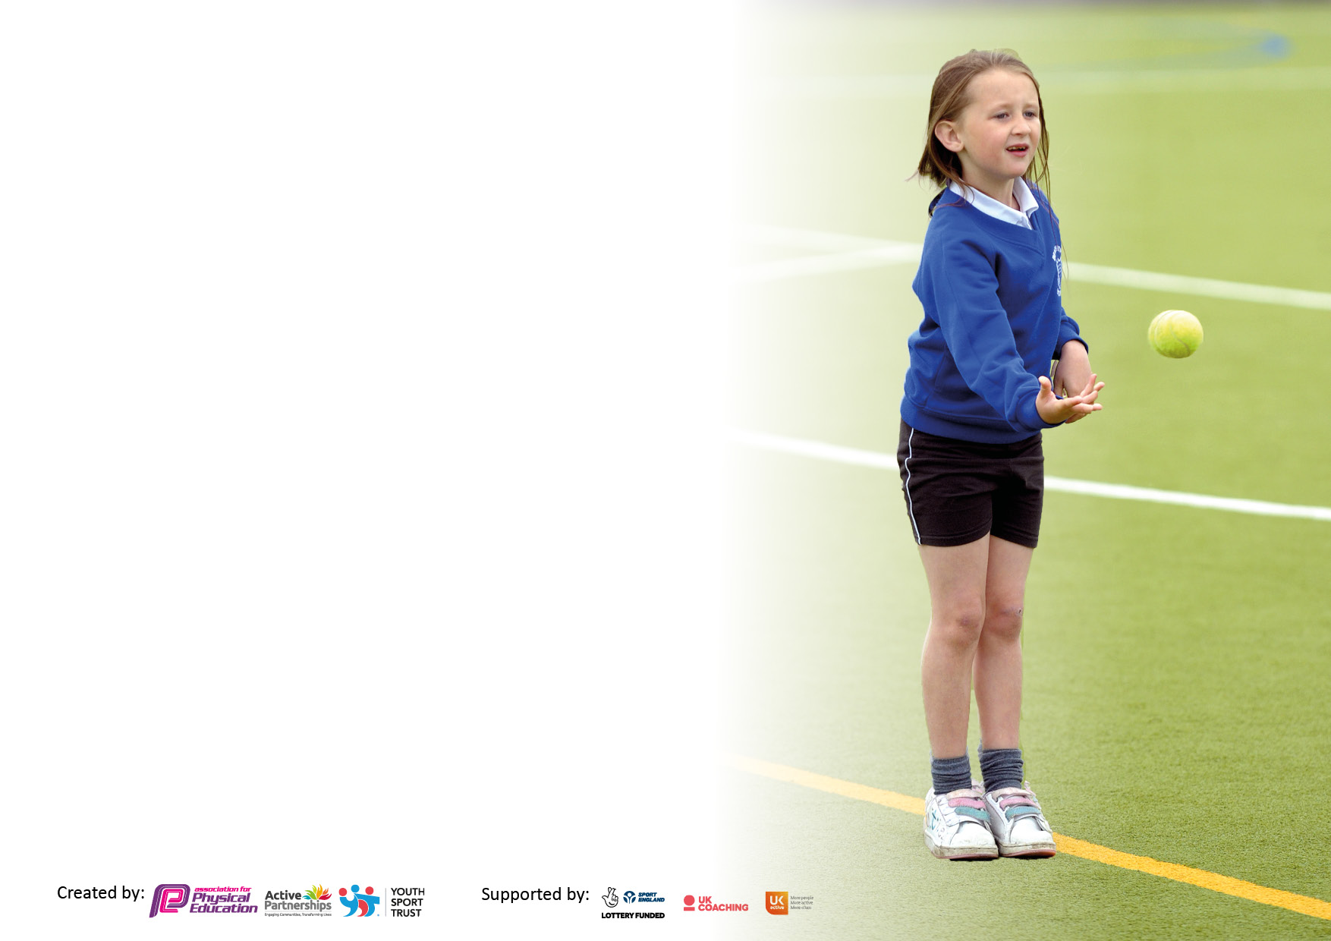

It is important that your grant is used effectively and based on school need. The [Education Inspection Framework](https://www.gov.uk/government/publications/education-inspection-framework) makes clear there will be a focus on **‘whether leaders and those responsible for governors all understand their respective roles and perform these in a way that enhances the effectiveness of the school’**.

Under the Quality of Education judgement, Ofsted inspectors consider:

**Intent** - Curriculum design, coverage and appropriateness

**Implementation** - Curriculum delivery, teaching (pedagogy) and assessment

**Impact** - Attainment and progress

To assist schools with common transferable language, this template has been developed to utilise the same three headings which should make your plans easily transferable between working documents.

Schools must use the funding to make additional and sustainable improvements to the quality of Physical Education, School Sport and Physical Activity (PESSPA) they offer. This means that you should use the Primary PE and sport premium to:

* Develop or add to the PESSPA activities that your school already offers
* Build capacity and capability within the school to ensure that improvements made now will benefit pupils joining the school in future years
* The Primary PE and sport premium should not be used to fund capital spend projects; the school’s budget should fund these.

Please visit <https://www.gov.uk/guidance/pe-and-sport-premium-for-primary-schools> for the revised DfE guidance, including the 5 key indicators across which schools should demonstrate an improvement. This document will help you to review your provision and to report your spend. DfE encourages schools to use this template as an effective way of meeting the reporting requirements of the Primary PE and Sport Premium.

We recommend you start by reflecting on the impact of current provision and reviewing the previous spend.

Schools are required to publish details of how they spend this funding, including any underspend from 2021/2022, as well as on the impact it has on pupils’ PE and sport participation and attainment.

We recommend regularly updating the table and publishing it on your website throughout the year. This evidences your ongoing self-evaluation of how you are using the funding to secure maximum, sustainable impact. Final copy must be posted on your website by the end of the academic year and no later than the 31 July 2023.

**Details with regard to funding**

Please complete the table below. Holy Name RC Primary School

|  |  |
| --- | --- |
| Total amount carried over from 2023/24 | £0 |
| Total amount allocated for 2023/24 | £17590 |
| How much (if any) do you intend to carry over from this total fund into 2024/25? | £0 |
| Total amount allocated for 2024/25 | £17650 |
| Total amount of funding for 2024/25 to be reported on by 31st July 2025 | £ 17650 |

**Swimming Data**

Please report on your Swimming Data below.

|  |  |
| --- | --- |
| Meeting national curriculum requirements for swimming and water safety.  **N.B.** Complete this section as best you can. For example, you might have practiced safe self-rescue techniques on dry land which you can then transfer to the pool when school swimming restarts.  **Due to exceptional circumstances priority should be given to ensuring that pupils can perform safe self-rescue even if they do not fully meet the first two requirements of the NC programme of study** |  |
| What percentage of your current Year 6 cohort swim competently, confidently and proficiently over a distance of at least 25 metres?  **N.B.** Even though your pupils may swim in another year, please report on their attainment on leaving primary school at the end of the summer term 2023.  Please see note above | 87% |
| What percentage of your current Year 6 cohort use a range of strokes effectively [for example, front crawl, backstroke and breaststroke]?  Please see note above | 57% |
| What percentage of your current Year 6 cohort perform safe self-rescue in different water-based situations? | 40% |
| Schools can choose to use the Primary PE and sport premium to provide additional provision for swimming, but this must be for activity **over and above** the national curriculum requirements. Have you used it in this way? | No |

**Action Plan and Budget Tracking**

Capture your intended annual spend against the 5 key indicators. Clarify the success criteria and evidence of impact that you intend to measure to evaluate for pupils today and for the future.

|  |  |  |  |  |
| --- | --- | --- | --- | --- |
| **Academic Year:** 2024/2025 | **Total fund allocated:** | **Date Updated:** | |  |
| **Key indicator 1:** Increase confidence, knowledge and skills of all staff in teaching PE and sport | | | | Percentage of total allocation: |
| 51% |
| **Intent** | **Implementation** | | **Impact** |  |
| Your school focus should be clear on what you want the pupils to know and be able to do. What do they need to learn and to consolidate through practice: | Make sure your actions to achieve are linked to your intentions: | Funding allocated: | Evidence of impact:  What do pupils now know and what can they now do? What has changed? | Sustainability and suggested next steps: |
| Improving subject knowledge    • Curriculum knowledge  • Knowledge of how to progress skills/plan effective lessons.  • Knowledge of expected standards.   * Knowledge of assessment for PE | • Increased confidence and ability to deliver curriculum PE across EYFS, KS1 and KS2.  • An evaluation of the current scheme for PE in terms of outcomes for pupils is undertaken and points for development are actioned.  • More confident teachers able to adapt plans to meet pupils' needs.  • Manchester City to provid CPD support across the school with staff  • CPD upskill PE subject leader accesses suitable CPD to upskill knowledge, skills and understanding. | £9,000 | More confident and competent staff  • Enhanced quality of teaching and learning  • Improved knowledge, skills and understanding with both staff and pupils  • Continued high level of pupil participation  • Enhanced, inclusive curriculum provision  • Positive attitudes to health and wellbeing  • Improved behavior  • Improved pupil attitudes to PE | PE subject Leader to support new staff in school with planning for delivery of physical education.  • Arrange team teaching opportunities and supportive lesson observations in order to develop the quality of teaching, learning and assessment.  • PE subject Leader to identify any staff who need further support and to provide appropriate professional learning. - Further professional learning opportunities for staff who request it.  • PE Subject Leader to monitor and to provide support as appropriate in order to ensure progress and achievement are maintained by all pupils. |
| **Key indicator 2:** The engagement of all pupils in regular physical activity – Chief Medical Officers’ guidelines recommend that  primary school pupils undertake at least 30 minutes of physical activity a day in school | | | | Percentage of total allocation: |
| 15% |
| **Intent** | **Implementation** | | **Impact** |  |
| Your school focus should be clear on what you want the pupils to know and be able to do. What do they need to learn and to consolidate through practice: | Make sure your actions to achieve are linked to your intentions: | Funding allocated: | Evidence of impact:  What do pupils now know and what can they now do? What has changed? | Sustainability and suggested next steps: |
| Increase physical activity and participation in EYFS, KS1 & KS2 at lunchtime, to engage pupils in at least 30mins of physical activity a day in school.  To continue to promote active travel to and from school through WOW.  Lunchtime Organisers and sports leaders to organise activities to increase physical activity and exercise.  Develop and expand Extra Curriculum Programme across the school.  Embed initiatives to develop knowledge of healthy living and active lifestyles across the whole school including EYFS | • Encourage the Daily Mile across the school. • Update outdoor play equipment to encourage physical exercise of children break and lunchtimes. • All classes to include an active warm up in every PE lesson.  • Appoint Identified pupils to act as sports leaders to boost activity and competition. Continue to train LO’s and sports leaders to increase physical activity and exercise at break times  • Continue to work in partnership with the Manchester PE Association and local schools, to improve participation rates and increase participation opportunities for all children.  • Investigate and commission new sporting initiatives to engage more children in physical activity during break times  • Continue to promote whole school physical activity and sports participation through whole school fun days (e.g. Sports Day…)To promote health and fitness through a range of activities during the curriculum and extracurricular and encourage the children to compete against themselves to improve scores and times  • Continue with healthy school food and drink policy, offering KS1 milk scheme, KS2 milk and fruit scheme and ensuring school provides a healthy and nutritious lunchtime meal including fresh drinking water and milk • Continue to audit food at breakfast and after school club ensuring children are offered healthy options • Share children’s ‘outside school’ sporting achievements in Good News Assembly. | £2,590 | • Observation  • School blog  • Website  • School competitions  • Science/PSHE work  • Healthy lunch boxes  • Water available in classrooms  • Pupils are knowledgeable regarding foods and healthy lifestyles.  • Teachers to regularly take pupils out for Daily runs | Ensure that Sports Leaders, LO’s and all staff continue to make PE high profile in the daily lives of children at HN  Teachers to consider how to make the classroom more active maybe an active starter or plenary activity at least once per day. Resources available to support with this www.activeschoolplanner.org www.classpal.org.uk Just Dance Gonoodle.com |

|  |  |  |  |  |
| --- | --- | --- | --- | --- |
| **Key indicator 3:** The profile of PE and sport is raised across the school as a tool for whole school improvement | | | | Percentage of total allocation: |
| 12% |
| **Intent** | **Implementation** | | **Impact** |  |
| Your school focus should be clear on what you want the pupils to know and be able to do. What do they need to learn and to consolidate through practice: | Make sure your actions to achieve are linked to your intentions: | Funding allocated: | Evidence of impact:  What do pupils now know and what can they now do? What has  changed? | Sustainability and suggested next steps: |
|  |  |  |  |  |
|  |  |  |  |  |
|  |  |  |  |  |
|  |  |  |  |  |
| Children will be provided with a wider range of sports which will increase the children’s participation in sport.  A wider range of sporting house competitions to be arranged throughout the year, during lunchtimes, after school and within the curriculum, to raise the range of after school sports to be offered over the week. Children to choose the sports they would like to participate in.  Develop Sports Leaders so more pupils are engaged in Sports themed days  Regular lunchtime and after school House Competitions. Participation in Manchester PE Association competitions. Participation in home fixtures and competitions in a variety of sports.  Continue to raise the profile of sport and encourage participation for all. Allow local clubs into school to help coach and promote their sports.    Opportunities for parents to be involved in sporting events (e.g. Sports Days…). Newsletters / website / twitter to further inform and promote sport within the school.  Continue to promote sport and sporting achievement throughout the school during weekly praise assemblies. Intended impact on pupils: - All pupils wanting to be active and to enjoy taking part in a range of sport, exercise and physical activity.  All pupils understanding the importance sport and physical activity plays in a healthy lifestyle. | A range of after school sports to be offered over the week. Children to choose the sports they would like to participate in.  There is an increase in the opportunity to allow children to participate in a variety of sports they may not otherwise get to try. egRacket  Sports Leaders effective and supporting activities leading younger children to participate in physical activities resulting in more positive role-models, positive reinforcement.  Purchase equipment to deliver a wide range of lunchtime and after school sports clubs. Competitions and games to be organised within year groups and with local schools both after school and during the school day  Locate and invite local clubs into school to help coach and promote their sports ie Lancashire county cricket  Sporting events to be arranged and parents invited to watch / participate  Continue to celebrate the achievements of all pupils at Good News assembly in physical activities that are both in school and in beyond the school gate  Children to take a lead on fitness within PE lessons and devise exercises / activities that the class can complete. (e.g. warm ups and stretches and creating and explaining their own games are engaged in | £2,060 | Sports themed days Regular lunchtime and Intra House Competitions in place increasing knowledge, understanding and skills.  Increase uptake on the number of children attending sporting clubs. Curriculum enhanced with a bigger variety of sporting opportunities on offer  Participation in Manchester PE Association competitions. Participation in home fixtures and competitions in a variety of sports increasing skills amongst children  More children accessing sporting venues across Manchester during the evening and at weekends.  Parental voice shows that they are happy with the PE provision on offer  More children are achieving medals and trophies in and outside of school and that they have increased aspirations for achieving in sporting activities | Ensure that a thorough analysis of staff, pupil and parent voice activities takes place and that all development points where possible to be implemented. |
| **Key indicator 4:** Broader experience of a range of sports and physical activities offered to all pupils | | | | Percentage of total allocation: |
| 11% |
| **Intent** | **Implementation** | | **Impact** |  |
| Your school focus should be clear on what you want the pupils to know and be able to do. What do they need to learn and to consolidate through practice: | Make sure your actions to achieve are linked to your intentions: | Funding allocated: | Evidence of impact:  What do pupils now know and what can they now do? What has  changed? | Sustainability and suggested next steps: |
|  |  |  |  |  |
|  |  |  |  |  |
|  |  |  |  |  |
|  |  |  |  |  |
| Continue to provide a three day outdoor pursuit residential to pupils in Year 5.  Use of pupil voice to ensure sports on offer are appealing to the children.  Continue to develop the Extracurricular Program across the school and to enter Manchester PE Association competitions  Outside agencies and clubs to come into school and offer a range of sports to the children in KS1 and KS2.  Increase the amount of opportunities for children to participate in outdoor pursuits | Ghylhead and coach booked. Trip subsidized to allow all pupils regardless of income to attend  Conduct a Pupil Voice PE activity and then implement points for action which may impact on the range of sports on offer  Support and train Sports leaders to design enrichment timetables, to impact on all areas of PE and sport.  Analyse assessment data to ensure that there is a good breadth and balance within the PE curriculum.    To continue to monitor the quality of the enrichment programme.  Continue to formulate links with a range of outside agencies / clubs to come into school to offer a range of sports, both during and outside of curriculum time. (E.g. Man City, Netball).  Organisation of special themed days and additional residential opportunities and days out for outdoor pursuits | £2,000 | All pupils to have experienced a variety of outdoor pursuits that they have never experienced before. Increased resilience and self esteem for all pupils.  All pupils given a broader experience in PE and extracurricular activities, as well as a wider range of sports being offered throughout the day.  Pupils knowledge, skills and understanding of PE continue to improve.  More pupils engage in a larger variety of sporting activities than the previous year including after school clubs |  |

|  |  |  |  |  |
| --- | --- | --- | --- | --- |
| **Key indicator 5:** Increased participation in competitive sport | | | | Percentage of total allocation: |
| 11% |
| **Intent** | **Implementation** | | **Impact** |  |
| Your school focus should be clear on what you want the pupils to know and be able to do. What do they need to learn and to consolidate through practice: | Make sure your actions to achieve are linked to your intentions: | Funding allocated: | Evidence of impact:  What do pupils now know and what can they now do? What has  changed? | Sustainability and suggested next steps: |
|  |  |  |  |  |
|  |  |  |  |  |
|  |  |  |  |  |
|  |  |  |  |  |
| Children to be provided with a range of opportunities to participate and compete in competitive sport.  Develop intra-school competitions in conjunction with partner-school.  Increased participation in sporting activities to include Intra & InterSchool competitions. | Increase the involvement of school in after school competitions  Use Man City coach to identify talented individuals, to then link with teachers to encourage outside sporting involvement  Use of funding to transport pupils to competitions. Cover to be arranged for teachers taking children to sports competitions during the school day.  Sports Leaders to organise and run sporting competitions at lunchtimes | £2,000 | More pupils will participate in competitive sport, including those with SEN.  Pupils regularly competing in a range of sports against other schools.  Entrance into Manchester PE Association Competitions Friendly fixtures against local schools.  Cover for staff to take teams to competitions Photos / Website / Twitter and Newsletter. • Fixture lists.  School Games Gold Mark maintained / Platinum Achieved.  Regular house competitions in school. More pupils will participate in competitive sport. | Competitions are part of school life and more pupils are competing beyond the school gate playing for local clubs and engaged in physical activity at local groups. |

|  |  |
| --- | --- |
| Signed off by | |
| Head Teacher: | Catherine Gordon |
| Date: | 20/09/2024 |
| Subject Leader: | Nicola Pugh |
| Date: | 20/09/2024 |
| Governor: | Charles Flannery |
| Date: | 20/09/2024 |